From: http://www.scmp.com/news/asia/south-asia/article/2040314/her-haunting-green-eyes-once-capitivated-world-she-now-faces-14

Her haunting green eyes once captivated the world. She now faces 14 years jail
PUBLISHED : Wednesday, 26 October, 2016, 7:54pm
UPDATED : Thursday, 27 October, 2016, 12:04pm
COMMENTS: 3
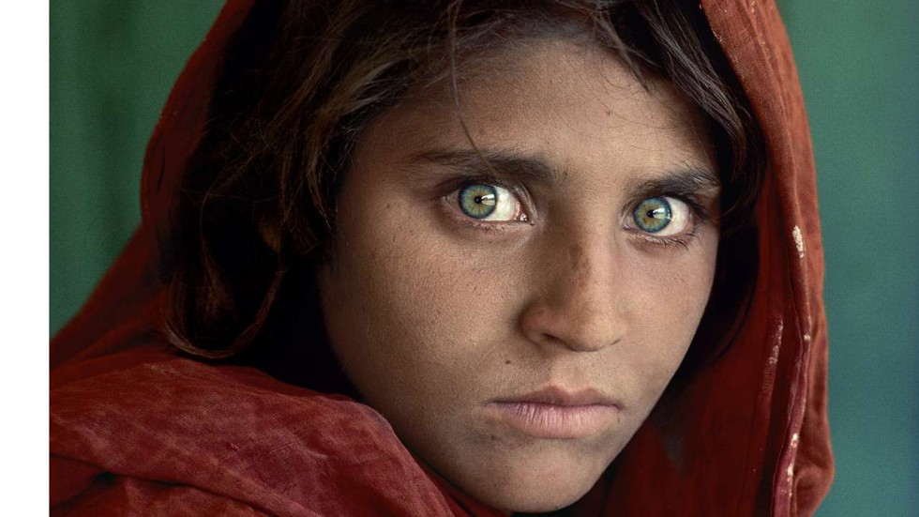

Agence France-Presse

413SHARE
3
PrintEmail
An Afghan woman immortalised on a celebrated National Geographic magazine cover as a green-eyed 12-year-old girl was arrested Wednesday for living in Pakistan on fraudulent identity papers.
The haunting image of Sharbat Gula, taken in a Pakistan refugee camp by photographer Steve McCurry in the 1980s, became the most famous cover image in the magazine’s history.
She now faces up to 14 years in jail - in an episode which highlights the desperate measures many Afghans are willing to take to avoid returning to their war-torn homeland as Pakistan cracks down on undocumented foreigners.
Pakistan’s Federal Investigation Agency (FIA) arrested Gul for fraud following a two-year investigation in the northwestern city of Peshawar, the capital of restive Khyber Pakhtunkhwa province bordering Afghanistan.
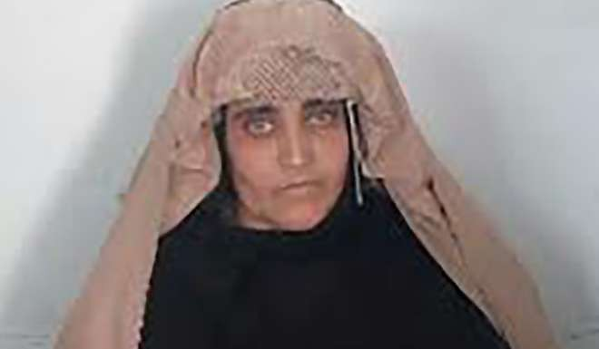
On show in Hong Kong: photographer’s searing images of Afghanistan
“FIA arrested Sharbat Gula, an Afghan woman, for obtaining a fake ID card,” Shahid Ilyas, an official of the National Database Registration Authority (NADRA), said.
Ilyas said the authorities were also seeking three NADRA officials found responsible for issuing Pakistan’s national identity card to Gula, who have been at large since the fraud was detected.
He said that Gula faces seven to 14 years in prison and a fine of $3,000-$5,000 if convicted.
Officials say Gula applied for a Pakistani identity card in Peshawar in April 2014, using the name Sharbat Bibi.
She was one of thousands of Afghan refugees who managed to dodge Pakistan’s computerised system to get an identity card.
Number of Afghan civilian casualties jumps to 5-year high, says UN report
The original image of Gula was taken in 1984 in a refugee camp in northwest Pakistan during the Soviet occupation of Afghanistan.
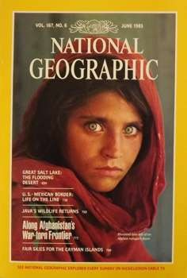
McCurry later tracked her down, after a 17-year search, to a remote Afghan village in 2002 where she was married to a baker and the mother of three daughters.
Pakistan has for decades provided safe haven for millions of Afghans who fled their country after the Soviet invasion of 1979.
The country hosts 1.4 million registered Afghan refugees, according to UNHCR, making it the third-largest refugee hosting nation in the world.
The agency also estimates a further one million unregistered refugees are in the country.
Since 2009, Islamabad has repeatedly pushed back a deadline for them to return, but fears are growing that the latest cutoff date in March 2017 will be final.
Thousands in Afghanistan demand justice for woman beaten to death by mob 'as police watched'
Meanwhile refugees are increasingly worried about their future in Pakistan as the country cracks down on those who have obtained fake ID cards.
Officials say NADRA has so far reverified 91 million ID cards and detected 60,675 fraudulent cards.
A NADRA official told AFP that 2,473 foreigners, mostly Afghans, had voluntarily surrendered their ID cards which were obtained fraudulently.
Some 18 NADRA officials were under investigation for issuing ID cards to foreigners and eight were arrested, the official said.
More than 350,000 Afghan refugees have returned home from Pakistan this year, UN data shows, with the torrent of people crossing the border expected to continue.
They face an uncertain future in an Afghanistan still at war and already overwhelmed by so many internally displaced people fleeing fighting that officials warn of a humanitarian crisis.
This article appeared in the South China Morning Post print edition as:
Nat Geo’s ‘Afghan girl’ cover star is arrested in Pakistan

